**SPICER ADVENTIST UNIVERSITY**



**DEPARTMENT OF COMPUTER SCIENCE**

**MICHAEL LALSAWMTLUANGA**

**21334001**

**ABSTRACT**

Emotion is a complex and multifaceted state of being, encompassing a wide range  of feelings and expressions. Recognizing these emotions in humans can be  challenging, but it is crucial for creating responsiveness. Detecting and identifying  human emotions is important in relation to the development or success of human computer interaction, artificial intelligence, and affective computing. Human emotion recognition based on facial expressions is of great significance in the  application of intelligent human-computer interaction. One prevalent approach is  the use of machine learning algorithms, particularly deep learning models like  Convolutional Neural Networks (CNN) and Recurrent Neural networks (RNN).

These models analyze facial expressions, vocal intonations, and physiological  signals such as heart rate and skin conductance to infer emotions. They rely on a  large datasets for training and can achieve impressive accuracy in emotion  recognition tasks. The application of emotion detection and identification are  diverse, ranging from personalized marketing and customer service to mental  health monitoring and therapeutic interventions. Emotion-aware AI systems can  adapt their responses to user emotions, providing a more tailored and empathetic  experience. In mental health care, these technologies can assist in early detection  of mood disorders and offer support to individuals in need.

**ACKNOWLEDGEMENT**

I would like to extend my gratitude to our Dean, **Dr. Susan Thomas** for giving me the opportunity to do this project on the topic.

I am profoundly indebted to my guide, **Mr. Risanlang Hynniewta** for guiding and helping me throughout this project. His expertise and insightful feedback have not only aided me in surmounting numerous challenges but have also significantly enriched my understanding and approach towards the subject matter, I offer my sincerest appreciation.

Your contributions have not only facilitated my personal and professional growth but have also left a lasting impact on my work.

I would like to thank all my friends for their help and support.

**SPICER ADVENTIST UNIVERSITY**

CERTIFICATE OF COMPLETION

A Project Report On

“**Detecting and Identifying Human Emotions**”

Submitted In Partial Fulfillment

Of The Degree Of

**Bachelor in Computer Science**

By

**MICHAEL LALSAWMTLUANGA**

**21334001**

Under The Supervision Of

**Risanlang Hynniewta**

Assistant Professor

For The Academic Year

**2024**

**SPICER ADVENTIST UNIVERSITY**

CANDIDATE DECLARATION

Detecting and Identifying Human Emotions

I, Michael Lalsawmtluanga (ID: 21334001), certify that this project is my own work, based on my personal study and research that I have acknowledged all material ad sources used in its preparation, whether they be books, articles, reports, lecture notes, and any other kind of documents, electronics or personal communication.

I also certify that this project has not previously been submitted for assessment in any academic capacity, and that I have not copied in part or whole or otherwise plagiarized the work of other persons.

ID: 21334001

Date: 10 April, 2024

**CERTIFICATE**

This is to certify that “Michael Lalsawmtluanga”(ID: 21334001) has worked in the, “Detecting and Identifying Human Emotions” has successfully completed the project, in partial fulfillment for the award of the degree of Bachelor of Science in Computer Science under my supervision.

Date: 10 April, 2024

Mr. Risanlang Hynniewta

Assistant Professor

**CERTIFICATE**

This is to certify that “Michael Lalsawmtluanga”(ID: 21334001) has worked in the, “Detecting and Identifying Human Emotions” has successfully completed the project, in partial fulfillment for the award of the degree of Bachelor of Science in Computer Science under my supervision.

Date: 10 April, 2024

Dr. Susan Thomas

Dean of Science

**Table Of Contents**

1. INTRODUCTION………………………………………………………………..1

1.1 Purpose of the project……………………………………………………...…3

1.2 Objectives………………………………………………………………….…4

1.3 Problem statement………………………………………………………..…..5

* 1. Propose approach………………………………………………………….....6

1. LITERATURE REVIEW…………………………………………………..…....8
2. METHODOLOGY AND PROJECT WORK……………………………….….12

3.1 Use case and UML diagram…………………………………………….…..13

3.2 Activity diagram………………………………………………………….…14

3.3 Data flow diagram…………………………………………………….….…16

1. IMPLEMENTATION………………………………………………………...…17

4.1 APPROACHES USED…………………………………………………..….17

4.1.1 Convolutional Neural Network(CNN)…………………………………….17

4.1.2 Four-Layer of CNN to facial emotion recognition(FER)………………....17

4.1.3. Analyze of facial expression………………………………………….….18

4.1.4. Facial emotion recognition (FER)……………………………………......18

4.1.5. Structure of CNN……………………………………………………..….19

1. SOURCE CODE…………………………………………………………….….20

5.1 Python language……………………………………………………….…....20

5.1.1 Python code……………………………………………………………….20

5.1.2 Python code in libraries…………………………………………….…..…23

1. EXPERIMENTAL RESULTS………………………………………….….……37
   1. Python code in libraries explanation……………………………….……..…37
2. CONCLUSION………………………………………………………….…...….41
3. FUTURE ENCHANCEMENT………………………………………….…..…..42
4. BIBLIOGRAPHY……………………………………………………….…..…..43

**1.INTRODUCTION**

Emotions play a very important function in many fields likes forensic crime detection,  psychologically affected patients, students mentoring in academics and victim observation in court, etc. The human face has several  components such as eye, nose, mouth, brow and a few others. Based on the movement of those components  and change of shape and sizes emotions may be extracted in various ways. Reorganization of emotion in  human has become a greatest challenge faced in the interaction of computer and humans. Most of the effort  on emotion recognition focuses on information extracted from visual or audio separately. Detecting and identifying emotions is a multidisciplinary field that relies on various techniques and approaches. These methods encompass both physiological and psychological indicators, as well as emerging technologies like artificial intelligence and machine learning. Some of the key techniques used to detect and identify human emotions, including facial expression analysis, voice analysis, physiological measurements, and advanced technology driven approaches. The universality of these expressions means that facial emotion recognition is a task that can also be accomplished by computers. Furthermore, like many other important tasks, computers can provide advantages over humans in analysis and problem-solving.One prevalent approach is  the use of machine learning algorithms, particularly deep learning models like  Convolutional Neural Networks (CNNs) and Recurrent Neural networks (RNNs). These models analyze facial expressions, vocal intonations, and physiological  signals such as heart rate and skin conductance to infer emotions. They rely on a  large dataset for training and can achieve impressive accuracy in emotion  recognition tasks. The application of emotion detection and identification are  diverse, ranging from personalized marketing and customer service to mental  health monitoring and therapeutic interventions. Emotion-aware AI systems can  adapt their responses to user emotions, providing a more tailored and empathetic  experience. Computers that can recognize facial expressions can find applications where efficiency and automation can be useful, including in entertainment, social media, content analysis, criminal justice, and healthcare. For example, content providers can determine the reactions of a consumer and adjust their future offerings accordingly.

The comprehension and interpretation of human emotions hold paramount significance across a spectrum of domains encompassing psychology, human-computer interaction, healthcare, and marketing. Within these arenas, the ability to discern emotional states from diverse sources such as written or spoken text, social media discourse, and conversational exchanges is pivotal. In response to this imperative, sentiment analysis methodologies have emerged, drawing upon diverse approaches including lexicon-based analysis, machine learning algorithms, and state-of-the-art transformer-based models. These methodologies are employed to extract nuanced emotional cues embedded within textual or verbal expressions.

Driven by technological advancements, an array of techniques has been developed to facilitate the accurate detection and identification of human emotions. This proposed research endeavors to undertake a comprehensive exploration and evaluation of the myriad methods and technologies deployed for the precise discernment and characterization of human emotional states. Through systematic inquiry and empirical investigation, this study seeks to illuminate the strengths, limitations, and potential applications of these methodologies, thereby contributing to the advancement of knowledge in this critical interdisciplinary domain.

Sentiment analysis techniques, based on lexicons, machine learning, or transformer-based models, can extract emotional cues from written or spoken text, social media post, and chat conversations. Advances in technology have led to the development of various techniques to detect and identify human emotions accurately. This research proposal aims to explore and evaluate different methods and technologies used for the detection and identification of human emotions.

**1.1. PURPOSE OF THE PROJECT**

Developing a sophisticated tool that leverages advanced image processing and artificial intelligence techniques to accurately analyze and interpret emotions conveyed in pictures. At its core, this initiative seeks to create a highly advanced tool that is capable of performing intricate analysis and interpretation of emotions expressed in pictures, employing cutting-edge image processing methodologies alongside sophisticated artificial intelligence algorithms. This technology is not just about recognizing basic emotions but delving deeper into the subtle expressions and complex emotional states expressing or communicating through images, thereby achieving a level of understanding previously thought to be the exclusive domain of human perception.

The overarching goal of this project is multifaceted. Primarily, it strives to diminish the longstanding divide that exists between the expressive capabilities of humans and the interpretative analyses by machines. By doing so, it opens up a very large amount of possibilities for application across various domains. In the realm of digital platforms, for instance, such a tool can dramatically enhance the user experience. It can enable software and applications to respond to the user's emotional state in real-time, providing a more intuitive and empathetic interface.

This could revolutionize the way we interact with technology, making digital experiences more personalized and emotionally aware.

By bridging the gap between human emotions and machine learning, it could pave the way for new research into the complexities of emotional intelligence, both artificial and human. This, in turn, could inform future advancements in AI, making machines not only more intelligent in the traditional sense but also more tune or adjust to the emotional dimensions of human intelligence.

**1.2. OBJECTIVES**

1.Developing a reliable automatic gesture recognition system like tracking head movements, detect face gesture such as eye blink, wink etc.

2.Provide an overview of the importance of detecting and identifying human emotions in various domain.

3.Adaptive system to adapt to condition or user overtime.

4.To review and analyze existing technique and technologies for emotion detection and identification.

5.To assess the effectiveness and accuracy of different method in real-world scenarios.

Explore potential applications and future directions in the field of facial recognition.

**1.3. PROBLEM STATEMENT**

The problem statement in detecting and identifying human emotions through pictures involves developing a computer vision system or an AI model that can analyze images or facial expressions to accurately recognize and categorize the emotions expressed by individuals. This may include tasks such as detecting emotions like happiness, sadness, anger, fear, surprise, and more in photographs or video frames. The goal is to create a system that can not only detect emotions but also accurately identify and label them, providing valuable insights for applications in various fields, such as healthcare, marketing, and human-computer interaction.

**The problems broken down into several key components:**

1. Image Input: The problem starts with acquiring images or video frames that contain human faces. These images could be obtained from various sources, including photos, videos, or live camera feeds.
2. Facial Detection: The first step is to detect and locate faces within the images. This is usually done using face detection algorithms or pre-trained models. Once the faces are detected, the focus is on the facial region.
3. Facial Feature Extraction: After detecting faces, the next step is to extract facial features that can be used to infer emotions. Key features include:Eyes: The shape, size, and openness of the eyes can indicate various emotions.Mouth: Lip curvature, the position of the corners of the mouth, and teeth exposure are critical.Brows: The position and shape of the eyebrows can convey emotional information.Wrinkles: Facial wrinkles, especially around the eyes and forehead, change with emotion.
4. Emotion Classification: Once facial features are extracted, the AI model needs to classify the emotion expressed in the face. Common emotions include happiness, sadness, anger, fear, surprise, disgust, and neutrality. The classification can be done using machine learning techniques such as convolutional neural networks (CNNs) or deep learning models like recurrent neural networks (RNNs).
5. Training Data: To build an effective emotion detection model, a vast data-set of labeled images is required. This data-set should include images with different individuals expressing various emotions under different lighting and environmental conditions.
6. Model Training: The AI model is trained on the labeled data-set using a supervised learning approach. During training, the model learns to recognize patterns and features in facial expressions that correspond to specific emotions.

**1.4. PROPOSED APPROACH**

1.Data Collection: Start by gathering a large data-set of images with labeled  emotions. This data-set should ideally include a variety of facial expressions  and emotions, such as happiness, sadness, anger, surprise, and more.

2.Preprocessing: Preprocess the images to ensure they are in a consistent  format. This may involve re-sizing, cropping, and converting them to  grayscale.

3.Experimentation & testing: Choose an appropriate machine learning or deep learning  model for emotion detection. Common choices include Convolutional  Neural Networks (CNNs), Recurrent Neural Networks (RNNs). Evaluate the model on a separate testing data-set to assess its  performance in a real-world scenario.

4.Post-processing: Post-process the model’s predictions to refine the emotion  detection results. This can include smoothing or filtering the predictions to  reduce noise.

5.Visualization: Visualize the results by overlaying emotion labels or  bounding boxes around detected faces in the images.

6.Deployment: Deploy the model to a real-world application or system where  it can analyze images in real-time or in batch processing.

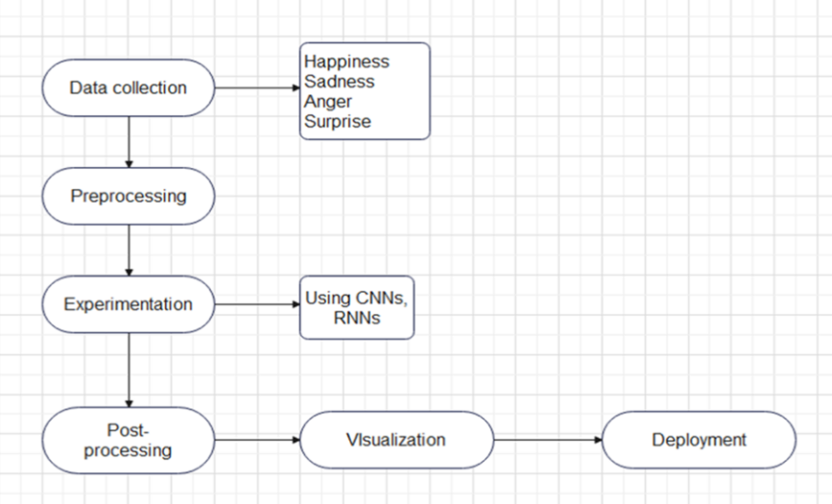

**Figure 2.** Proposed approach

**2. LITERATURE REVIEW**

Abdullah, S. M. S. A., Ameen, S. Y. A., Sadeeq, M. A., & Zeebaree, S. (2021), build a machine learning models that can be trained to recognized a specific pattern, such as Convolutional Neural Networks(CNNs) and Recurrent Neural Networks(RNNs), have been applied to emotion recognition tasks, achiving impressive results.

Babajee, P., Suddul, G., Armoogum, S., & Foogooa, R. (2020), identified human emotions from facial expressions with deep learning like CNNs(deep learning model inspired by the human visual system), involves using large datasets of facial images to train deep learning models to recognize patterns associated with different emotions. In which training models to automatically analyze facial expressions and infer human emotions from raw image data.

Bandi, R., & Amudhavel, J. (2018) studied an object recognition which is the process of identifying and categorizing objects within digital images or video frames using Keras, a high-level deep learning library, offers a user-friendly interface for building and training neural networks, with  backend tensor flow providing efficient execution of computations on various hardware platforms.

1. Kim,J.Roh,S.Dong & S.Lee (2016), studied Hierarchical committee of deep  convolutional neural networks for robust facial expression  recognition, then provides a comprehensive overview of how combining multiple CNN models in a structured way can lead to more accurate and reliable emotion detection from facial images. It underscores the potential of such approaches to advance the field and contribute to the development of more empathetic and intuitive human-machine interfaces.

Cruz-Albarran, I. A., Benitez-Rangel, J. P., Osornio-Rios, R. A., & Morales-Hernandez, L. A. (2017), studied human emotions detection based on a smart-thermal system of thermographic images, thermal imaging, or thermography, is a technique that captures the infrared radiation emitted by objects, allowing the visualization of temperature changes. which dive deeper into an overview of how thermal imaging technology can be applied to identify emotional states based on physiological changes.

D. Tjondronegoro, & Zhang L. (2011), analyzed the movements and configurations of facial expression recognition using facial movement features involves facial muscles to infer the emotional state of an individual. These features include the positions, orientations, and movements of key facial landmarks such as the eyes, eyebrows, mouth, and nose.

Fengyuan Wang, Jianhua Lv, Guode Ying, Shenghui Chen, & Chi Zhang (2019), studied facial expression recognition from image  based on hybrid features understanding to dig into the integration of various types of features derived from facial images to improve the accuracy and robustness of facial expression recognition systems. Using hybrid features would provide a comprehensive overview of how combining multiple types of data extracted from images can lead to more accurate and reliable recognition of facial expressions.

G Hemalatha, and CP Sumathi (2014), studied the techniques for facial detection and expression classification, which provides a comprehensive overview of the methodologies, advancements, challenges, and applications in these critical areas of research.

I. M. Revina, & W. R. Sam Emmanuel (2018), did a Survey on Human Face Expression Recognition Techniques, which involves systematically reviewing and summarizing existing research studies, methodologies, and findings related to the identification of emotions from facial expressions.

Karilingappa, K., Jayadevappa, D., & Ganganna, S. (2023), studied human emotion detection and classification using convolutional neural networks, in which reviewing and analyzing how these advanced computational models are applied to interpret human emotions from visual data, typically images or video frames of faces. And explains why understanding human emotions is crucial for various applications, including mental health assessment, enhancing user experience in technology, and improving human-computer interaction.

K.Oatley, & E.Duncan (2004), studied the Experience of Emotions in Everyday Life,  Journal of Cognitive Emotions. Provides with an insightful overview into how emotions are experienced, regulated, and impact individuals across different contexts of their daily lives. It highlights the complexity of human emotions, the influence of external factors, and the implications for personal and societal well-being.

Kulkarni, P., & Rajesh, T. M. (2020), did an examination on the strategies of the methods employed to detect and categorized human emotions. And then analyzed the various methods and approaches used in research and practical applications in understanding and interpreting human emotions.

Ming-Hsuan Yang, D. J. Kriegman, & N. Ahuja (2002), did a survey on detecting faces in images encapsulates a comprehensive review and analysis of methodologies, technologies, and progress in the field of facial detection, which involves gathering insights from a wide range of studies to evaluate how different techniques perform the task of identifying faces within digital images.

P. Ekman, & W. V Friesen (2002), provides a facial action coding system (FACS) a comprehensive overview of manual methodology for analyzing facial expressions, covering its principles, applications, advantages, limitations, validation, and future directions. Which serves as a valuable resource for researchers, practitioners, and students interested in understanding and utilizing FACS in various fields of study.

Triyanti, V., Yassierli, Y., & Iridiastadi, H. (2019), utilized computer vision and image processing to analyze facial expressions and detect emotions by examining important facial characteristics such as eye movements, mouth, shape and brow furrows.

Venkatesan, R., Shirly, S., Selvarathi, M., & Jebaseeli, T. J. (2023), studied Human Emotion Detection Using Deep Face and Artificial Intelligence, which represents a cutting-edge intersection of technology, psychology, and computer science. It leverages the capabilities of deep learning—a subset of machine learning—to analyze, recognize, and interpret human emotions from facial expressions.

Wafi, M., Bachtiar, F. A., & Utaminingrum, F. (2023), did a comparison of feature extraction for facial expression recognition using adaptive extreme learning machine(ELM), which provide insights into the effectiveness of different techniques. And explains how ELM works by randomly initializing the weights between input and hidden layers and analytically determining the output weights, bypassing the iterative optimization process used in traditional neural networks.

Yadav, S. P. (2021), studied emotion recognition model based on facial expressions, that explore the various techniques and methodologies used to develop models that can identify and interpret human emotions from facial expressions.provides an overview of the methods, applications, and challenges in this rapidly evolving field.

Zhang, L., & Tian, Q. (2021), optimized a novel fuzzy CNN-RNN method for facial

expression recognition, involves refining and enhancing the architecture, parameters, and training procedures of the model to improve its performance.

**3. METHODOLOGY AND PROJECT WORK**

Emotion detection using the facial components suggested before is still being used. It was mainly observed that for emotion detection we need to do it by stage by stage. Preprocessing is the first stage, and then comes the feature extraction and then the classification. As the year passed there has been lot of growth and advancement in these three stages with different variety of algorithms. In the present observations more number of features are extracted from the faces to verify the emotions. Recognition in the form of facial emotion and expression has additionally been increased. Recently because of fast development of machine learning and artificial intelligent (AI) techniques, as well as the human computer interaction, a computer game (VR), augment reality (AR). Detection of facial expression in advanced driver assistant systems and recreation is also found. Although the technology for recognizing emotions is important and has evolved in different fields, it is still the unanswered problem.

The procedure for recognizing emotions is not simple but complex because it extracts the appropriate characteristics and Detecting emotions requires complex steps.The Facial Expression Recognition (FER) consists of five phases as shown in Figure 1. Noise elimination/improvement is performed in the preprocessing phase take an image or a sequence of images as an input face for further processing. Detection of facial components detects return on investment in eyes, nose, cheeks, mouth, eyes, forehead, ear, front head, etc.

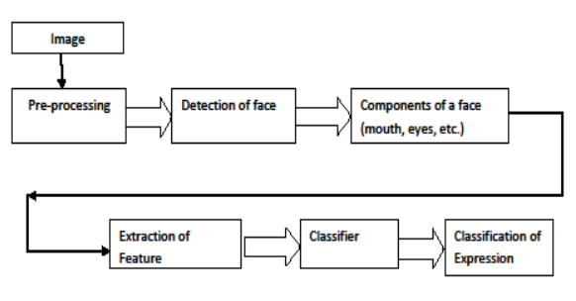

**Figure 1.** Phases of facial expression recognition

**3.1. USE CASE AND UML DIAGRAM**

A use case is fundamentally a description of a series of actions or steps, typically performed by a system, to achieve a particular goal or provide a specific value to a user or another system. In a use case diagram, this is represented by a horizontal ellipse.

Use cases describe a flow of events or a sequence of steps. This flow is initiated by an actor to achieve an objective. UML activity diagrams are a dynamic tool for modeling the sequence of operations and the flow of control within a system. They build upon the elements of state diagrams but focus more on the operational aspects and internal processing flows, making them indispensable for documenting and analyzing workflows from the business level down to the operational level.

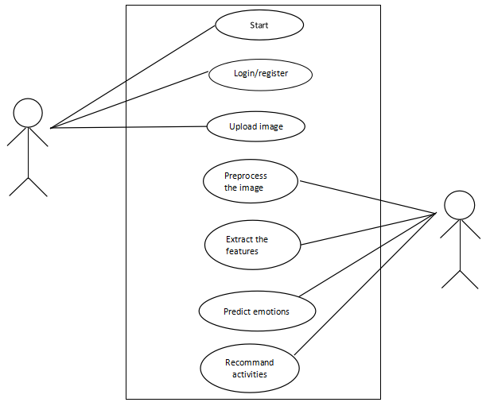

**Figure 3.** Use case Diagram

**3.2. ACTIVITY DIAGRAM**

An activity diagram is a type of diagram in the Unified Modeling Language (UML) that illustrates the workflow or procedural logic of a system, process, or algorithm. It visualizes the sequence of activities, actions, and transitions that occur within the system, highlighting the flow of control from one activity to another.

The flow from one activity to other activity can be represented by 'Activity Diagram'.

**Activity diagram for Training:**

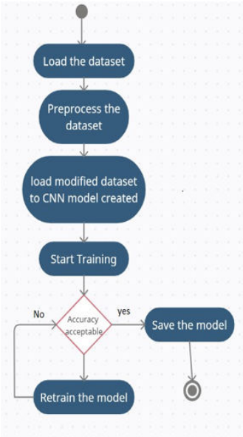

**Figure 4.** Activity diagram for training

**Activity Diagram for Testing:**

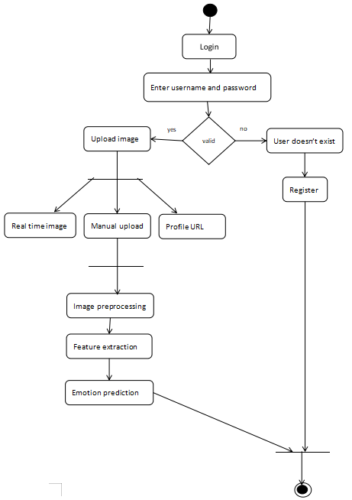

**Figure 5.** Activity diagram for testing

**3.3. DATA FLOW DIAGRAM**

A Data Flow Diagram (DFD) is a graphical representation of the flow of data within a system. It illustrates how data moves from external sources, through processes, and ultimately to storage or output destinations. DFD are used in software engineering and systems analysis to model the structure and behavior of systems in a clear and concise manner. The physical data flow diagrams show the actual implements and movement of data between people, departments and workstations.

**Data Flow diagram for Training:**

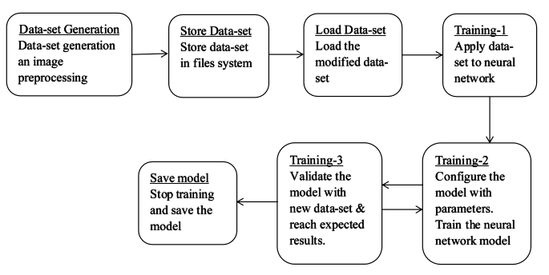

**Figure 6.** Data Flow diagram for Training

**Data Flow diagram for Testing:**

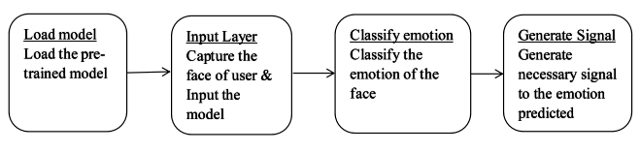

**Figure 6.** Data Flow diagram for testing

**4. IMPLEMENTATION**

**4.1. APPROACHES UESD**

**4.1.1. CONVOLUTIONAL NEURAL NETWORK(CNN)**

A Convolutional Neural Network (CNN) is a powerful deep learning architecture specifically designed to analyze visual data, mimicking the way the human visual cortex processes information. At its core, a CNN comprises multiple layers, each serving a unique purpose in extracting hierarchical features from input images. The first layer, typically a convolutional layer, applies convolution operations by sliding small filters across the input image to detect patterns and features like edges, textures, and shapes. These filters, also known as kernels, capture local spatial information, allowing the network to learn increasingly complex representations as information flows through subsequent layers.

One of the artificial neural network, used in image recognition is CNN. A CNN is a type of artificial neural network used in image recognition. This comes under category of multi-layer perceptron.

**4.1.2. Four-layer of CNN to facial emotion recognition(FER):**

The face is also known as the mental core. As an assortment of facial gestures, the face can give several minimal signals. These exquisite signals can make human–machine interaction more secure and harmonious when interpreted by computers. A good source of knowledge for ordering an individual’s true emotions1 was argued for facial expressions. Recognition of facial expression (FER) is one of the most critical non-verbal processes by which human–machine interface (HMI) systems can understand2 human intimate emotions and intentions.

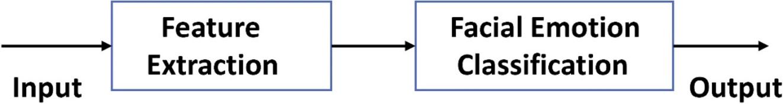

**Figure 7.** A simple structural view of facial expression recognition system

**4.1.3. Analyze of facial expression**

Automatic facial expression analysis (AFEA) can be used in many areas, including relational and semantic communication, clinical psychology, psychiatry, neurology, pain assessment, lie detection, intelligent settings, and multi-modal human–computer interface (HCI). Face collection, facial data extraction and representation, and recognition of facial expression are three steps of the standard approach to AFEA composition, as depicted in Fig.8 . There are mainly two types of techniques for facial feature extraction: geometric or predictive feature-based methods and methods based on appearances. Te authors used the combination of statistical appearance-based and geometric feature-based approaches in this article.

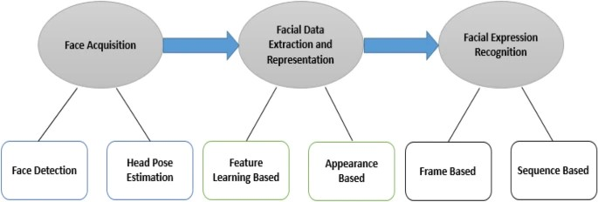

**Figure 8.** The basic framework of applications in many areas for automatic facial expression analysis

**4.1.4. Facial emotion recognition (FER)**

Face detection is a key role in FER. There are different strategies to face recognition, including the expression-based approach, the framework approach, the feature-based approach, and the neighborhood graph approach19. The three-stage flow map of the facial expression recognition process seen in the Fig. 9.

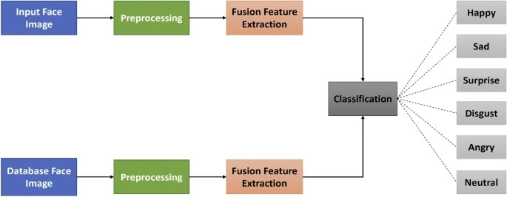

**Figure 9.** Summary flowchart of the 3 phases of the facial expression recognition(FER) method

**4.1.5. Structure of CNN**

At first, we see a simple CNN template with several building blocks that we can easily understand and correlate to the proposed CNN model. Tree types of layers make up a basic CNN as illustrated in Fig. 10, input, hidden, and output. The data enters the CNN via the input layer and then travels through many hidden levels before reaching the output layer. The network’s prediction is reflected via the output layer. In terms of loss or error, the network’s output is compared to the actual labels.

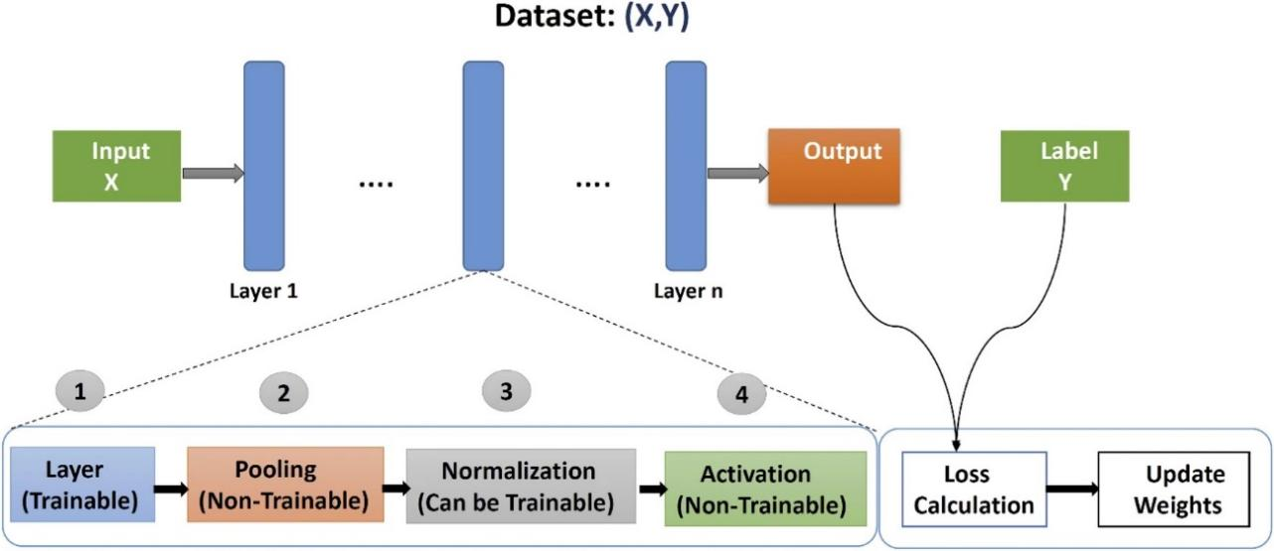

**Figure 10.** The template of a basic CNN

**5. SOURCE CODE**

**5.1. PYTHON LANGUAGE**

Python is a high-level, interpreted programming language known for its simplicity, readability, and versatility. Python abstracts many complex details of programming, making it easier to write and understand code. And this code is executed line by line by the Python interpreter, without the need for compilation. This makes the development process faster and more interactive. Python can be used for a wide range of purposes including web development, data analysis, machine learning, artificial intelligence, scientific computing, automation, scripting, and more.

**5.1.1. PYTHON CODE:**

from keras.models import load_model

from time import sleep

from keras.preprocessing.image import img_to_array

from keras.preprocessing import image

import cv2

import numpy as np

face_classifier=cv2.CascadeClassifier(r'C:\Users\Admin\pythonProject\EmotionDetectionCNN\haarcascade_frontalface_default.xml')

classifier=load_model(r'C:\Users\Admin\pythonProject\EmotionDetectionCNN\model.h')

emotion_labels = ['Angry','Disgust','Fear','Happy','Neutral', 'Sad', 'Surprise']

cap = cv2.VideoCapture(0)

while True:

_, frame = cap.read()

labels = []

gray = cv2.cvtColor(frame,cv2.COLOR_BGR2GRAY)

faces = face_classifier.detectMultiScale(gray)

for (x,y,w,h) in faces:

cv2.rectangle(frame,(x,y),(x+w,y+h),(0,255,255),2)

roi_gray = gray[y:y+h,x:x+w]

roi_gray = cv2.resize(roi_gray,(48,48),interpolation=cv2.INTER_AREA)

if np.sum([roi_gray])!=0:

roi = roi_gray.astype('float')/255.0

roi = img_to_array(roi)

roi = np.expand_dims(roi,axis=0)

prediction = classifier.predict(roi)[0]

label=emotion_labels[prediction.argmax()]

label_position = (x,y)

cv2.putText(frame,label,label_position,cv2.FONT_HERSHEY_SIMPLEX,1,(0,255,0),2)

else:

cv2.putText(frame,'NoFaces',(30,80),cv2.FONT_HERSHEY_SIMPLEX,1,(0,255,0),2)

cv2.imshow('Emotion Detector',frame)

if cv2.waitKey(1) & 0xFF == ord('q'):

break

cap.release()

cv2.destroyAllWindows()

**EXPLANATON:**

**Importing Libraries:**

**from keras.models import load_model**

**from time import sleep**

**from keras.preprocessing.image import img_to_array**

**from keras.preprocessing import image**

**import cv2**

**import numpy as np**

keras: Importing functions related to loading and processing the model.

time: Importing `sleep` for optional delay.

cv2: OpenCV library for computer vision tasks.

numpy: Library for numerical computations.

Loading Pre-trained Model and Cascade Classifier

**face_classifier = cv2.CascadeClassifier(r'C:\Users\Admin\pythonProject\EmotionDetectionCNN\haarcascade_frontalface_default.xml')**

**classifier = load_model(r'C:\Users\Admin\pythonProject\EmotionDetectionCNN\model.h5')**

face_classifier: Loading the Haar cascade classifier for face detection.

Classifier: Loading the pre-trained model for emotion detection using Keras' load_model function.

Defining Emotion Labels

**emotion_labels = ['Angry','Disgust','Fear','Happy','Neutral', 'Sad', 'Surprise']**

List of emotion labels corresponding to the output of the model.

Initializing Video Capture

**cap = cv2.VideoCapture(0)**

Initializes video capture from the default webcam (index 0).

**while True:**

**_, frame = cap.read()**

**gray = cv2.cvtColor(frame,cv2.COLOR_BGR2GRAY)**

**faces = face_classifier.detectMultiScale(gray)**

**for (x,y,w,h) in faces:**

**# Face Detection and Emotion Prediction**

**...**

**cv2.imshow('Emotion Detector',frame)**

**if cv2.waitKey(1) & 0xFF == ord('q'):**

**break**

The loop continuously captures frames from the webcam, converts them to grayscale, detects faces using the Haar cascade classifier, predicts emotions for each detected face, and overlays the predicted emotion label on the frame. The loop exits when the user presses the 'q' key.

Displaying the Output:

The processed frame with emotion labels is displayed using `cv2.imshow`.

**cap.release()**

**cv2.destroyAllWindows()**

- Releases the video capture and closes all OpenCV windows after the loop exits.

**5.1.2. PYTHON CODE IN LIBRARIES**

In [1]: **import** matplotlib.pyplot **as** plt

**import** numpy **as** np

**import** pandas **as** pd

**import** seaborn **as** sns

**import** os

**from** keras.preprocessing.image **import** load_img, img_to_array

**from** keras.preprocessing.image **import** ImageDataGenerator

**from** keras.layers **import** Dense,Input,Dropout,GlobalAveragePooling3D,Flatten,Conv2D,BatchNormalization,Activation,MaxPooling2D

**from** keras.models **import** Model,Sequential

**from** keras.optimizers **import** Adam,SGD,RMSprop

In [2]:

picture_size **=** 48

folder_path **=** "../input/face-expression-recognition-dataset/images/"

In [3]:

expression **=** 'sad'

plt**.**figure(figsize**=**(12,12))

**for** i **in** range(1, 10, 1):

plt**.**subplot(3, 3, i)

img **=** load_img(folder_path**+**"train/"**+**expression**+**"/"**+**

os**.**listdir(folder_path **+** "train/" **+** expression)[i], target_size**=**(picture_size, picture_size))

plt**.**imshow(img)

plt**.**show()

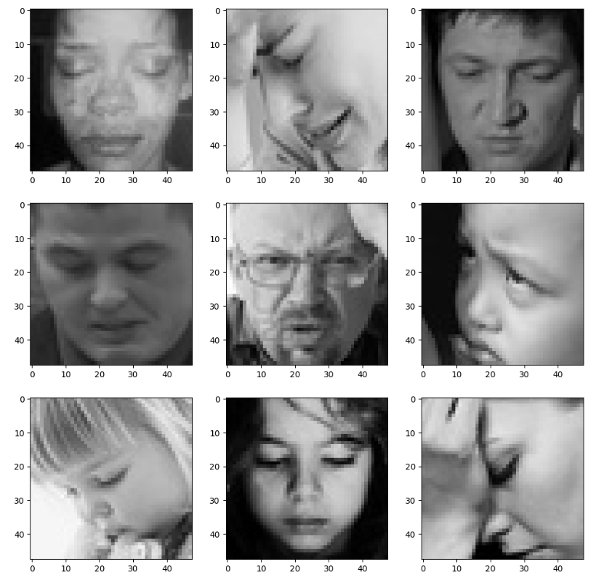

**What this code essentially does is it creates a visual representation of nine images depicting sadness, each loaded from the folder path provided. It's a simple way to visualize a subset of the data-set for a specific expression, in this case, sadness. This type of visualization can be useful for inspecting the data and understanding what it looks like before building and training a machine learning model.**

In [4]:

expression=['sad','angry','disgust','fear','happy','neutral','surprise']

**for** j **in** range(0,len(expression)):

plt**.**figure(figsize**=**(12,12))

**for** i **in** range(1, 10, 1):

plt**.**subplot(3, 3, i)

img=load_img(folder_path**+**"train/"**+**expression[j]**+**"/"**+**os**.**listdir(folder_path **+** "train/" **+** expression[j])[i], target_size**=**(picture_size, picture_size))

plt**.**imshow(img)

plt**.**show()

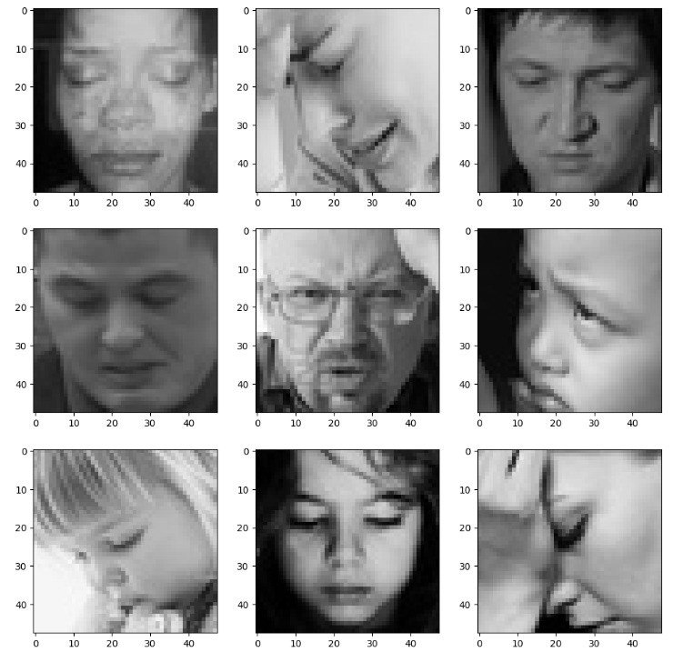

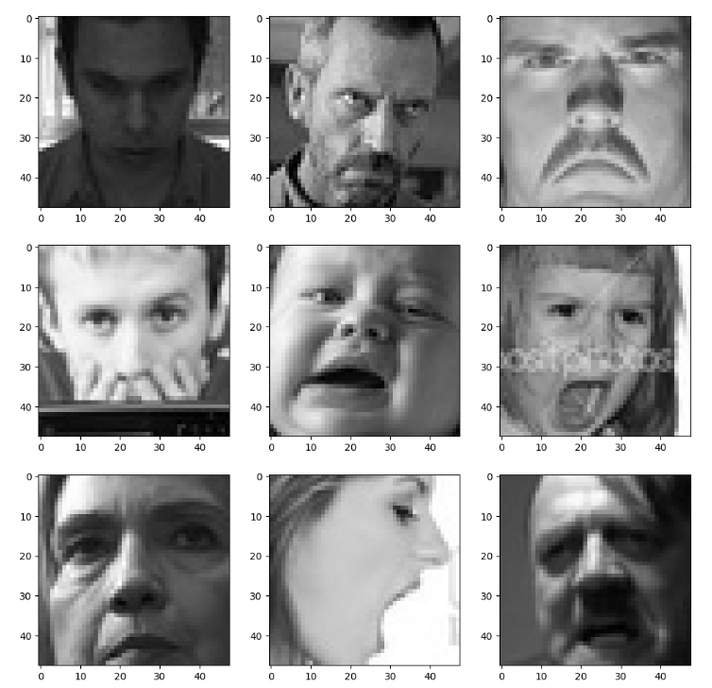

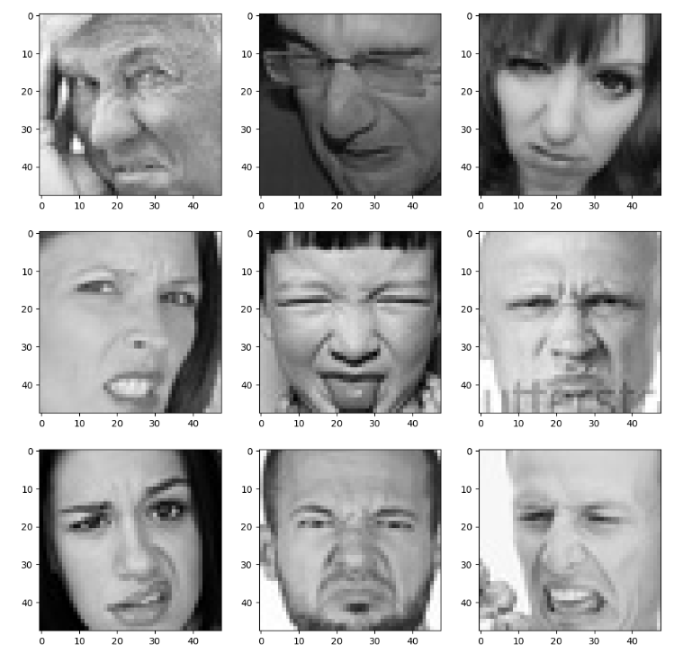

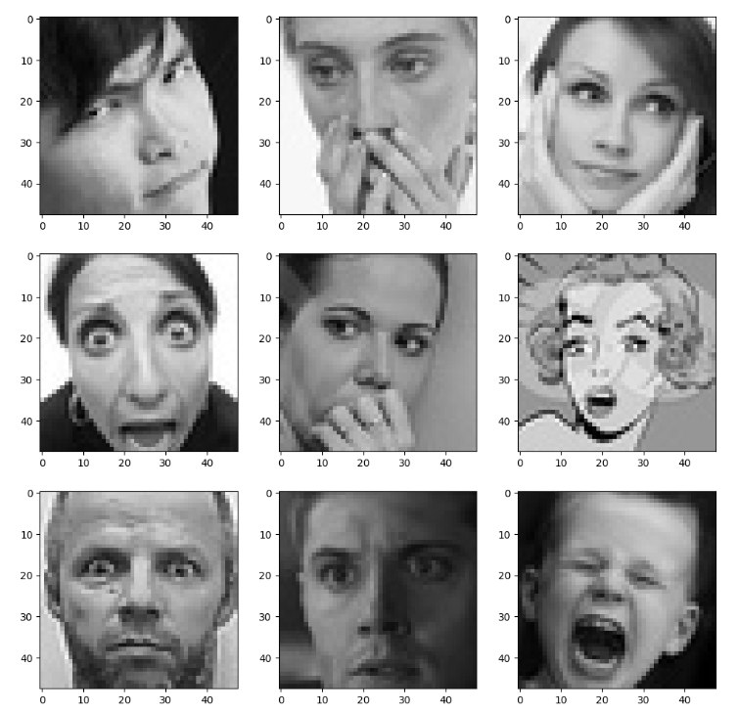

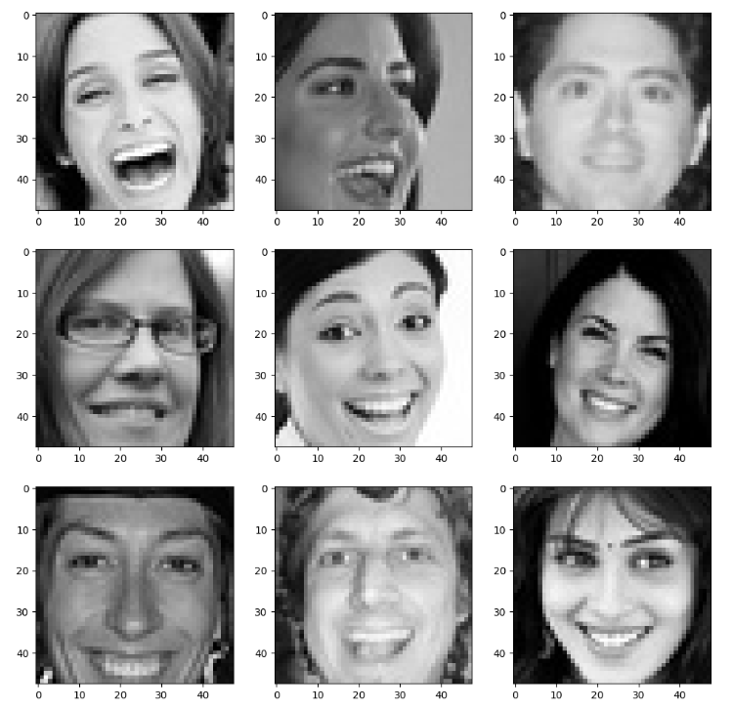

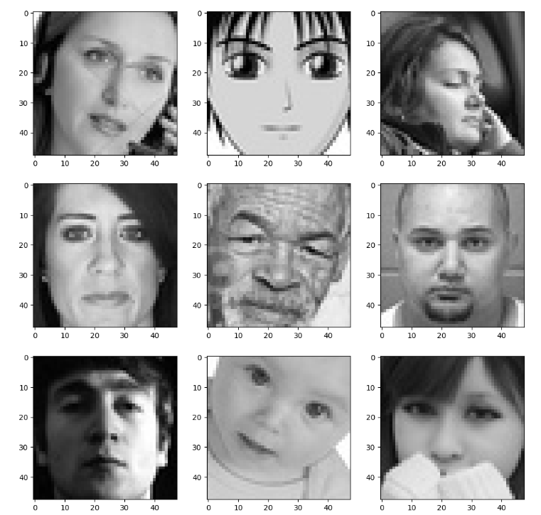

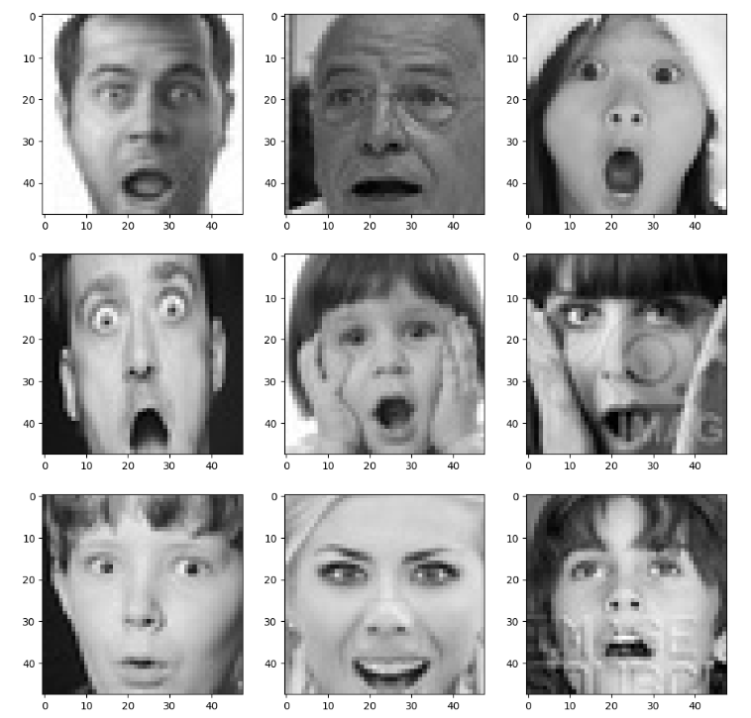

**The loaded image is displayed in the current subplot using `plt.imshow(img)`. Once all 9 images are displayed, the figure is shown using `plt.show()`.**

**This code creates a set of visualizations where for each expression, it displays a 3x3 grid of images representing that expression. It allows for a quick inspection of the images corresponding to different facial expressions in the dataset, aiding in data exploration and understanding.**

In [5]:

batch_size **=** 128

datagen_train **=** ImageDataGenerator()

datagen_val **=** ImageDataGenerator()

train_set **=** datagen_train**.**flow_from_directory(folder_path**+**"train",

target_size **=** (picture_size,picture_size),

color_mode **=** "grayscale",

batch_size**=**batch_size,

class_mode**=**'categorical',

shuffle**=True**)

test_set **=** datagen_val**.**flow_from_directory(folder_path**+**"validation",

target_size **=** (picture_size,picture_size),

color_mode **=** "grayscale",

batch_size**=**batch_size,

class_mode**=**'categorical',

shuffle**=False**)

Found 28821 images belonging to 7 classes.

Found 7066 images belonging to 7 classes.

**This code sets up data generators to load images from directories for training and validation. It specifies parameters like batch size, target image size, and color mode for preprocessing. The training set is shuffled, while the validation set is not shuffled to maintain consistency during evaluation. These generators will be used to feed batches of preprocessed images into the model during training and evaluation.**

In [6]:

**from** keras.optimizers **import** Adam,SGD,RMSprop

no_of_classes **=** 7

model **=** Sequential()

model**.**add(Conv2D(64,(3,3),padding **=** 'same',input_shape **=** (48,48,1)))

model**.**add(BatchNormalization())

model**.**add(Activation('relu'))

model**.**add(MaxPooling2D(pool_size **=** (2,2)))

model**.**add(Dropout(0.25))

model**.**add(Conv2D(128,(5,5),padding **=** 'same'))

model**.**add(BatchNormalization())

model**.**add(Activation('relu'))

model**.**add(MaxPooling2D(pool_size **=** (2,2)))

model**.**add(Dropout (0.25))

model**.**add(Conv2D(512,(3,3),padding **=** 'same'))

model**.**add(BatchNormalization())

model**.**add(Activation('relu'))

model**.**add(MaxPooling2D(pool_size **=** (2,2)))

model**.**add(Dropout (0.25))

model**.**add(Conv2D(512,(3,3), padding**=**'same'))

model**.**add(BatchNormalization())

model**.**add(Activation('relu'))

model**.**add(MaxPooling2D(pool_size**=**(2, 2)))

model**.**add(Dropout(0.25))

model**.**add(Flatten())

model**.**add(Dense(256))

model**.**add(BatchNormalization())

model**.**add(Activation('relu'))

model**.**add(Dropout(0.25))

model**.**add(Dense(512))

model**.**add(BatchNormalization())

model**.**add(Activation('relu'))

model**.**add(Dropout(0.25))

model**.**add(Dense(no_of_classes, activation**=**'softmax'))

opt **=** Adam(lr **=** 0.0001)

model**.**compile(optimizer**=**opt,loss**=**'categorical_crossentropy', metrics**=**['accuracy'])

model**.**summary()

Model: "sequential"

_________________________________________________________________

Layer (type) Output Shape Param #

=================================================================

conv2d (Conv2D) (None, 48, 48, 64) 640

batch_normalization (Batch (None, 48, 48, 64) 256 Normalization)

activation (Activation) (None, 48, 48, 64) 0

max_pooling2D(MaxPooling2 (None, 24, 24, 64) 0

D)

dropout (Dropout) (None, 24, 24, 64) 0

conv2d_1 (Conv2D) (None, 24, 24, 128) 204928

batch_normalization_1 (Bat (None, 24, 24, 128) 512 chNormalization)

activation_1 (Activation) (None, 24, 24, 128) 0

max_pooling2d_1 (MaxPoolin (None, 12, 12, 128) 0

g2D)

dropout_1 (Dropout) (None, 12, 12, 128) 0

conv2d_2 (Conv2D) (None, 12, 12, 512) 590336

batch_normalization_2 (Bat (None, 12, 12, 512) 2048

chNormalization)

activation_2 (Activation) (None, 12, 12, 512) 0

max_pooling2d_2 (MaxPoolin (None, 6, 6, 512) 0 g2D)

dropout_2 (Dropout) (None, 6, 6, 512) 0

conv2d_3 (Conv2D) (None, 6, 6, 512) 2359808

batch_normalization_3 (Bat (None, 6, 6, 512) 2048 chNormalization)

activation_3 (Activation) (None, 6, 6, 512) 0

max_pooling2d_3 (MaxPoolin (None, 3, 3, 512) 0 g2D)

dropout_3 (Dropout) (None, 3, 3, 512) 0

flatten (Flatten) (None, 4608) 0

dense (Dense) (None, 256) 1179904

batch_normalization_4 (Bat (None, 256) 1024 chNormalization)

activation_4 (Activation) (None, 256) 0

dropout_4 (Dropout) (None, 256) 0

dense_1 (Dense) (None, 512) 13154

batch_normalization_5 (Bat (None, 512) 2048 chNormalization)

activation_5 (Activation) (None, 512) 0

dropout_5 (Dropout) (None, 512) 0

dense_2 (Dense) (None, 7) 3591

=================================================================

Total params: 4478727 (17.08 MB)

Trainable params: 4474759 (17.07 MB)

Non-trainable params: 3968 (15.50 KB)

_________________________________________________________________

**The code we provided defines a convolutional neural network (CNN) model using the Keras library with TensorFlow backend.**

**In simple terms, the code defines a CNN model for classifying facial expressions. It consists of multiple convolutional layers followed by batch normalization, ReLU activation, max pooling, and dropout layers. The output of the convolutional layers is flattened and passed through dense layers for classification. Finally, the model is compiled with appropriate optimizer, loss function, and metrics for training and evaluation.**

In [7]:

**from** keras.optimizers **import** RMSprop,SGD,Adam

**from** keras.callbacks **import** ModelCheckpoint, EarlyStopping, ReduceLROnPlateau

checkpoint **=** ModelCheckpoint("./model.h5", monitor**=**'val_acc', verbose**=**1, save_best_only**=True**, mode**=**'max')

early_stopping **=** EarlyStopping(monitor**=**'val_loss',

min_delta**=**0,

patience**=**3,

verbose**=**1,

restore_best_weights**=True**

)

reduce_learningrate **=** ReduceLROnPlateau(monitor**=**'val_loss',

factor**=**0.2,

patience**=**3,

verbose**=**1,

min_delta**=**0.0001)

callbacks_list **=** [early_stopping,checkpoint,reduce_learningrate]

epochs **=** 48

model**.**compile(loss**=**'categorical_crossentropy',

optimizer **=** Adam(lr**=**0.001),

metrics**=**['accuracy'])

**We used this code to sets up various strategies to monitor and optimize the training process of a neural network model. It saves the best-performing model weights,stops training early if no improvement is seen, and adjusts the learning rate dynamically to ensure effective model training and avoid overfitting. These techniques collectively help in improving the model's performance and generalization ability.**

In [8]:

history **=** model**.**fit_generator(generator**=**train_set, steps_per_epoch**=**train_set**.**n**//**train_set**.**batch_size,

epochs**=**epochs,

validation_data **=** test_set,

validation_steps **=** test_set**.**n**//**test_set**.**batch_size,

callbacks**=**callbacks_list

)

Epoch 1/48

/tmp/ipykernel_33/3853974908.py:1: UserWarning: `Model.fit_generator` is deprecated and will be removed in a future version. Please use `Model.fit`, which supports generators.

history = model.fit_generator(generator=train_set,

225/225 [==============================] - 572s 2s/step - loss: 1.6886 - accuracy: 0.3561 - val_loss: 2.2708 - val_accuracy: 0.2661 - lr: 0.0010

Epoch 2/48

225/225 [==============================] - 518s 2s/step - loss: 1.3636 - accuracy: 0.4803 - val_loss: 1.3815 - val_accuracy: 0.4634 - lr: 0.0010

Epoch 3/48

225/225 [==============================] - 515s 2s/step - loss: 1.2281 - accuracy: 0.5327 - val_loss: 1.4027 - val_accuracy: 0.4812 - lr: 0.0010

Epoch 4/48

225/225 [==============================] - 515s 2s/step - loss: 1.1553 - accuracy: 0.5612 - val_loss: 1.2257 - val_accuracy: 0.5266 - lr: 0.0010

Epoch 5/48

225/225 [==============================] - 516s 2s/step - loss: 1.0896 - accuracy: 0.5844 - val_loss: 1.1384 - val_accuracy: 0.5676 - lr: 0.0010

Epoch 6/48

225/225 [==============================] - 513s 2s/step - loss: 1.0416 - accuracy: 0.6033 - val_loss: 1.3138 - val_accuracy: 0.4896 - lr: 0.0010

Epoch 7/48

225/225 [==============================] - 517s 2s/step - loss: 0.9948 - accuracy: 0.6243 - val_loss: 1.0935 - val_accuracy: 0.5911 - lr: 0.0010

Epoch 8/48

225/225 [==============================] - 515s 2s/step - loss: 0.9512 - accuracy: 0.6402 - val_loss: 1.0792 - val_accuracy: 0.6028 - lr: 0.0010

Epoch 9/48

225/225 [==============================] - 517s 2s/step - loss: 0.9138 - accuracy: 0.6557 - val_loss: 1.2211 - val_accuracy: 0.5470 - lr: 0.0010

Epoch 10/48

225/225 [==============================] - 517s 2s/step - loss: 0.8655 - accuracy: 0.6752 - val_loss: 1.0223 - val_accuracy: 0.6249 - lr: 0.0010

Epoch 11/48

225/225 [==============================] - 515s 2s/step - loss: 0.8264 - accuracy: 0.6915 - val_loss: 1.1242 - val_accuracy: 0.5814 - lr: 0.0010

Epoch 12/48

225/225 [==============================] - 521s 2s/step - loss: 0.7724 - accuracy: 0.7080 - val_loss: 1.1219 - val_accuracy: 0.5943 - lr: 0.0010

Epoch 13/48

225/225 [==============================] - ETA: 0s - loss: 0.7357 - accuracy: 0.7226Restoring model weights from the end of the best epoch: 10.

Epoch 13: ReduceLROnPlateau reducing learning rate to 0.00020000000949949026.

225/225 [==============================] - 517s 2s/step - loss: 0.7357 - accuracy: 0.7226 - val_loss: 1.1242 - val_accuracy: 0.5964 - lr: 0.0010

Epoch 13: early stopping

**This code starts the training process of a neural network model using the specified data generators (`train_set` for training data and `test_set` for validation data). It trains the model for a specified number of epochs while monitoring and applying the defined callbacks. The training progress and performance metrics are stored in the `history` object for further analysis. This approach allows for efficient training of models on large datasets, as data is generated on-the-fly in batches during training.**

In [9]:

**from** tensorflow.keras.preprocessing **import** image

**import** matplotlib.pyplot **as** plt

**import** numpy **as** np

image_size **=** (48, 48)

img **=** image**.**load_img("/kaggle/input/face-expression-recognition-dataset/images/train/sad/10006.jpg", target_size**=**image_size)

plt**.**imshow(img)

img_array **=** image**.**img_to_array(img)

img_array **=** np**.**expand_dims(img_array, axis**=**0)

print()

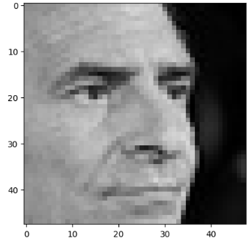

**In this code we upload an image file, resizes it to a specified size, displays it using matplotlib, converts it into a NumPy array, and then prepares it for further processing, such as passing it through a neural network for prediction or analysis. It's a common preprocessing step in machine learning tasks involving image data.**

In [10]:

plt**.**style**.**use('dark_background')

plt**.**figure(figsize**=**(20,10))

plt**.**subplot(1, 2, 1)

plt**.**suptitle('Optimizer : Adam', fontsize**=**10)

plt**.**ylabel('Loss', fontsize**=**16)

plt**.**plot(history**.**history['loss'], label**=**'Training Loss')

plt**.**plot(history**.**history['val_loss'], label**=**'Validation Loss')

plt**.**legend(loc**=**'upper right')

plt**.**subplot(1, 2, 2)

plt**.**ylabel('Accuracy', fontsize**=**16)

plt**.**plot(history**.**history['accuracy'], label**=**'Training Accuracy')

plt**.**plot(history**.**history['val_accuracy'], label**=**'Validation Accuracy')

plt**.**legend(loc**=**'lower right')

plt**.**show()

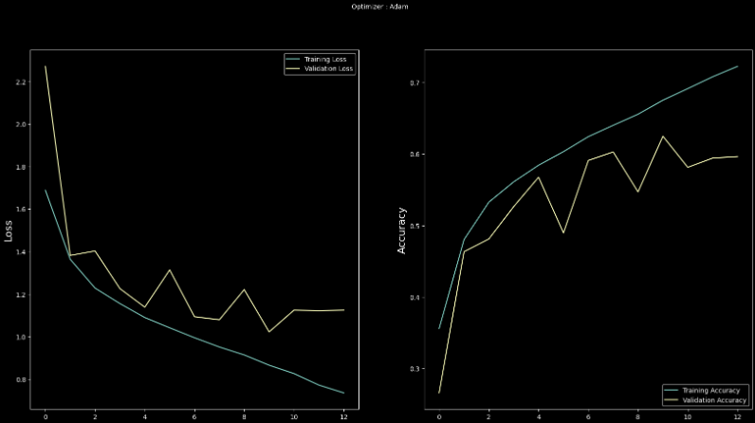

**We used the code to visualize the training progress of a neural network model that has been trained using the Adam optimizer.**

**This code creates a figure with two subplots: one for plotting loss curves and the other for plotting accuracy curves during the training of a neural network model using the Adam optimizer. The curves provide insights into how the model's performance changes over epochs, helping to assess its training progress and potential over-fitting.**

**6. EXPERIMENTAL RESULTS**

**6.1. PYTHON CODE IN LIBRARY EXPLANATION**

In [3]:

expression **=** 'sad'

plt**.**figure(figsize**=**(12,12))

**for** i **in** range(1, 10, 1):

plt**.**subplot(3, 3, i)

img **=** load_img(folder_path**+**"train/"**+**expression**+**"/"**+**

os**.**listdir(folder_path **+** "train/" **+** expression)[i], target_size**=**(picture_size, picture_size))

plt**.**imshow(img)

plt**.**show()

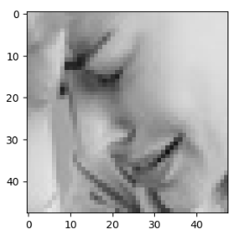

In [4]:

expression=['sad','angry','disgust','fear','happy','neutral','surprise']

**for** j **in** range(0,len(expression)):

plt**.**figure(figsize**=**(12,12))

**for** i **in** range(1, 10, 1):

plt**.**subplot(3, 3, i)

img=load_img(folder_path**+**"train/"**+**expression[j]**+**"/"**+**os**.**listdir(folder_path **+** "train/" **+** expression[j])[i], target_size**=**(picture_size, picture_size))

plt**.**imshow(img)

plt**.**show()

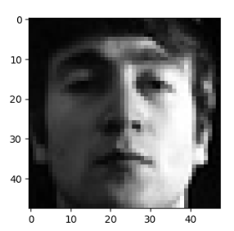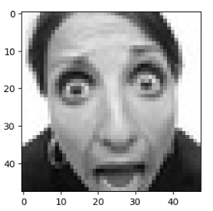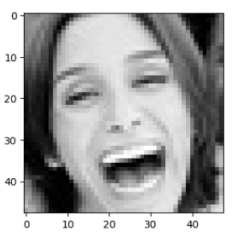 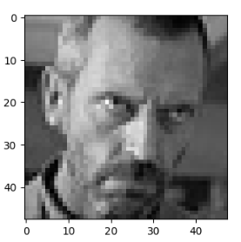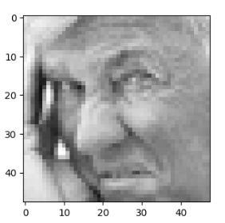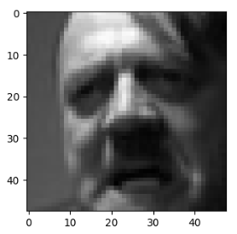****

**Using this code we creates a set of visualizations where for each expression, it displays a 3x3 grid of images representing that expression. It allows for a quick inspection of the images corresponding to different facial expressions in the dataset, aiding in data exploration and understanding.**

In [9]:

**from** tensorflow.keras.preprocessing **import** image

**import** matplotlib.pyplot **as** plt

**import** numpy **as** np

image_size **=** (48, 48)

img **=** image**.**load_img("/kaggle/input/face-expression-recognition-dataset/images/train/sad/10006.jpg", target_size**=**image_size)

plt**.**imshow(img)

img_array **=** image**.**img_to_array(img)

img_array **=** np**.**expand_dims(img_array, axis**=**0)

print()



**In this code we upload an image file, resizes it to a specified size, displays it using matplotlib, converts it into a NumPy array, and then prepares it for further processing, such as passing it through a neural network for prediction or analysis. It's a common preprocessing step in machine learning tasks involving image data.**

In [10]:

plt**.**style**.**use('dark_background')

plt**.**figure(figsize**=**(20,10))

plt**.**subplot(1, 2, 1)

plt**.**suptitle('Optimizer : Adam', fontsize**=**10)

plt**.**ylabel('Loss', fontsize**=**16)

plt**.**plot(history**.**history['loss'], label**=**'Training Loss')

plt**.**plot(history**.**history['val_loss'], label**=**'Validation Loss')

plt**.**legend(loc**=**'upper right')

plt**.**subplot(1, 2, 2)

plt**.**ylabel('Accuracy', fontsize**=**16)

plt**.**plot(history**.**history['accuracy'], label**=**'Training Accuracy')

plt**.**plot(history**.**history['val_accuracy'], label**=**'Validation Accuracy')

plt**.**legend(loc**=**'lower right')

plt**.**show()



**Here we used this code to visualize the training progress of a neural network model that has been trained using the Adam optimizer. Adam, SGD(Stochastic Gradient Descent) and RMSprop are popular optimization algorithms used to update network weights during training.**

**CONCLUSION**

In conclusion, this research proposal outline focus on investigating techniques for detecting and identifying human emotions. It highlights the importance of this research in advancing emotion recognition technology and its applications across various domain. The techniques for emotion detection and identifyication have significant evolution, primarily propelled by advancements in machine learning and multimodal data analysis. This evolution implies that the field has seen improvements in accuracy, efficiency, and applicability. These  techniques hold promise for enhancing human-computer interaction (HCI)and enabling a  wide array of applications across industries. By accurately detecting human emotions, AI systems can better understand and respond to user needs, thereby enchancing Hci experiences. Additionally, personalized content delivery can be achived based in user emotions, leading to more engaging and tailored interactions. Furthermore, the accurate emotion detecton has implicationa for enchancing well-being. For instance, in healthcare setting, AI systems could assist in monitoring and addressing emotional states, potentially improving mental health outcomes. Looking forward, the proposal anticipates further advancements in the field of emotion recognition technology. These advancements may result in even more sophisticated and emotionally intelligent AI systems. Such systems could revolutionize various sectors by enabling more responsive interactions between human and machines. The proposed research aims to contribute to the ongoing development of emotion recognition technology, with potential to significantly impact human-machine interaction, personalized content delivery, enhanced well-being and various industries.

**FUTURE ENCHANCEMEN**

Advanced Machine Learning Algorithms will continued advancements in machine learning techniques, such as deep learning, reinforcement learning, and ensemble methods, will likely lead to more accurate and robust emotion detection models. These models will be better equipped to handle complex and nuanced emotional expressions.

Future systems may leverage a combination of various data sources, including facial expressions, vocal cues, body language, physiological signals (such as heart rate and skin conductance), and textual inputs (such as social media posts or chat transcripts). Integrating multiple modalities can improve the reliability and richness of emotion detection. And emotion detection systems will become more sophisticated in understanding contextual cues that influence emotional states. Includings considering factors such as situational context, cultural norms, individual differences, and historical data about the user's emotions and behaviors.

Furthermore, the advancements in wearable technology and sensor integration will enable real-time and continuous monitoring of emotional states. This could have applications in various domains, including mental health monitoring, personalized advertising, and adaptive learning environments. As emotion detection technology becomes more pervasive, there will be increased attention to ethical considerations and potential biases in the algorithms. Future enhancements will focus on developing fair and transparent systems that prioritize user privacy, consent, and equity.

The future enhancements of emotion detection and identification will enable more accurate, context-aware, and ethically responsible systems that can positively impact human-computer interaction, personalization, and well-being in numerous domains.

**BIBLIOGRAPHY**

Abdullah, S. M. S. A., Ameen, S. Y. A., Sadeeq, M. A., & Zeebaree, S. (2021).

Multimodal emotion recognition using deep learning. Journal of Applied Science

and Technology Trends, 2(02), 52-58.

Babajee, P., Suddul, G., Armoogum, S., & Foogooa, R. (2020). Identifying human emotions from facial expressions with deep learning. In *2020 zooming innovation in consumer technologies conference (ZINC)* (pp. 36-39). IEEE.

Bandi, R., & Amudhavel, J. (2018). Object recognition using Keras with  backend tensor flow. International Journal of Engineering and  Technology (UAE), 7(3.6 Special Issue 6), 229-233.

1. Kim,J.Roh,S.Dong and S.Lee (2016),”Hierarchical committee of deep  convolutional neural networks for robust facial expression  recognition”Journal on Multimodal User Interfaces,pp,1-17.

Cruz-Albarran, I. A., Benitez-Rangel, J. P., Osornio-Rios, R. A., & Morales-Hernandez, L. A. (2017). Human emotions detection based on a smart-thermal system of thermographic images. *Infrared Physics & Technology*, *81*, 250-261.

D. Tjondronegoro, and Zhang, L. (2011), “Facial Expression Recognition using Facial Movement Features,” *IEEE  Transactions on Affective Computing,* vol. 2, no. 4, pp. 219-229.

FengyuanWang, Jianhua Lv, Guode Ying, Shenghui Chen, Chi Zhang, “Facial Expression Recognition from Image  based on Hybrid Features Understanding,” *Journal of Visual Communication and Image Representation,* vol. 59,  pp. 84-88, 2019.

G Hemalatha, and CP Sumathi, “A Study of Techniques for Facial Detection and Expression Classification,” *International Journal of Computer Science and Engineering Survey,* vol. 5, no. 2, pp. 27-37, 2014.

I. M. Revina, and W. R. Sam Emmanuel, “A Survey on Human Face Expression Recognition Techniques,” *Journal of King Saud University-Computer and Information Sciences,* 2018.

Karilingappa, K., Jayadevappa, D., & Ganganna, S. (2023). Human emotion detection

and classification using convolutional neural networks. IAES International Journal

of Artificial Intelligence, 12(1), 79.

K.Oatley, and E.Duncan, the Experience of Emotions in Everyday Life,  Journal of Cognitive Emotions, 2004, 369-381

Kulkarni, P., & Rajesh, T. M. (2020). Analysis on techniques used to recognize and

identifying the Human emotions. International Journal of Electrical and Computer

Engineering, 10(3), 3307.

Ming-Hsuan Yang, D. J. Kriegman, and N. Ahuja (2002), “Detecting Faces in Images: A survey,” *IEEE Transactions on  Pattern Analysis and Machine Intelligence,* vol. 24, no. 1, pp. 34-58.

P. Ekman, & W. V Friesen (2002), “Facial action coding system: Manual,” *Palo Alto, Calif: Consulting Psychologists Press*.

Triyanti, V., Yassierli, Y., & Iridiastadi, H. (2019). Basic emotion recognition using

automatic facial expression analysis software. Jurnal Optimasi Sistem Industri,

18(1), 55-64.

Venkatesan, R., Shirly, S., Selvarathi, M., & Jebaseeli, T. J. (2023). Human Emotion Detection Using DeepFace and Artificial Intelligence. *Engineering Proceedings*, *59*(1), 37.

Wafi, M., Bachtiar, F. A., & Utaminingrum, F. (2023). Comparison of feature extraction for facial expression recognition using adaptive extreme learning machine.

International Journal of Electrical and Computer Engineering, 13(1), 1113-1122.

Yadav, S. P. (2021). Emotion recognition model based on facial expressions. *Multimedia Tools and Applications*, *80*(17), 26357-26379.

Zhang, L., & Tian, Q. (2021). Optimization of a Novel Fuzzy CNN-RNN Method for Facial Expression Recognition. *Elektronika ir Elektrotechnika*, *27*(5), 67-74.

https://github.com/lianLiante22